Dear Lynda,
I hope this finds you well. You may like to just read through this on a rainy day, nothing pivotal but some of it may be of interest.
One more item from your visit which I was able to add to (below)
From: lynda.rich
To: nigeldouglasgb@hotmail.com
Subject: RE: Chipping Warden Douglas'
Hello Nigel,
I found a “Register of men marrying in Northants. not resident at place of marriage” and among these was in 1809 Thomas Douglas of CW marrying Mary Douglas at Badby, which suggests that the Douglas families in different villages could be related and Thomas could have married a cousin. This was Thomas 55, son of Thomas 45 and Elizabeth Inns. No sign of Mary being baptized in Badby? They lived in CW, their son Thomas is the last baptism in the CW PR.
I managed to get a couple of days in Northants in the summer and this time took infrared pictures of graves. These have provided some better information than we had, but still not solved the main puzzle. I was able to locate the grave of William 10 d.1712 and 7 associated graves (3 without memorials). I need to do some post-production on the pictures to further this line of research, but I have appended my preliminary findings.
When I laid out my charts to add new information, I had a kind of Damascene moment. What if Thomas 1B wasn’t the descendent of an unknown 16th century Douglas, but the first son of Thomas 1A? If you moved 1A’s assumed birthdate forward a couple of years and gave 1B a birth year of 1598 (just before PRs were kept of baptisms) it would work perfectly. In the first instance I had attached importance to the spelling Douglasse, but that was a mistake. My only pause for thought here is the will of Owen 4. In it he refers to his loving friend William, not nephew, but even this is not conclusive one way or the other.
“To my wife Amy and son Thomas all
the rest of my goods and chattells
Wife Amy to be sole executrix and loving friends William Dowglas, Thomas Lynes and
Richard Lamprey to be overseers of the will
Proved by Anna Douglas 9 Feb 1666/7
There is another group of 5 graves to the right of the church, dating from the mid 1800s to 1940, which deepen the mystery of missing baptisms.
I think we are fairly sure that William Douglas 46, a baker, (1751 - ?) married Sarah Bateman (? – 1804). There are recorded births of children William 1785, John 1789, Mary 1791 and Owen 1793.
In your list of marriages you have:
03.05.1807 William Borton (All Saints, Northampton) m. Elizabeth Douglas d/o William Douglas (Baker) by licence. Both signed, witnesses: Daniel Douglas and Sarah Douglas, both signed.
We assumed Elizabeth to be born around 1781 a 1st child, but who was the witness Daniel? I found the grave of Daniel Bateman Douglas (c1783 – 1851) and his wife Elizabeth, which seems to solve that small mystery. Daniel may have been married twice (firstly to an Ann) Just before he died, he owned the Griffin Inn in CW and farmed 200 acres, employing several people ( among them Richard Douglas 65* the illegitimate son of Mary Douglas daughter of Thomas 36 and Frances).
I spent an hour with Mrs Bartlett, the Senior Churchwarden at CW. She knows a lot, but you have to tease it out of her and she declined to elaborate on the more sordid details she alluded to know. Her ancestors had lived in CW, close to the Manor House, where John Douglas 62 lived with his wife Elizabeth (she was referred to as ‘Milady’ apparently). They farmed 300 acres. John’s brother George 57 lived at Hog End and farmed 200 acres. His son Thomas Henry Douglas had a farm of 280 acres in 1861 and lived at Edgecote House!! (Rented I guess from the Chauncy trust, but heh). Apparently when the CW Douglas’ started to get thin on the ground, there was a stampede of relatives of any distance, to claim some inheritance.
The dangers of relying on Dna*. The two Douglas families I have had contact with in New Zealand and claim to descend from the CW family were both non-starters. One is descended from an illegitimate relationship in Badby and the other family (who thought they descended from George & Joanna) are according to my research, descended from the illegitimate Richard 65 mentioned above.
I spent a very enjoyable morning at Cropredy and this extract is from an e-mail I got from Sue Lester, the Churchwarden.
I can confirm from Cropredy Parish Registers that ‘George DOUGLAS of Chipping Warden, Northants.’, married ‘Joanna LANGLY of Coton in the parish of Cropredy ‘ at Cropredy church on 17th April 1715’ .

Neither George or Joanna appear in Cropredy baptism registers. Chipping Warden is a small village about 3-4 miles from Cropredy which has its own church. It is however in the county of Northamptonshire and I do not have access to their parish registers. If Chipping Warden parish registers are not available online it might be worth asking Northamptonshire Family History Society if they have been transcribed.

Coton was a small hamlet (now redundant with few, if any, houses remaining) close to the village of Wardington. Wardington is about one and half miles from Cropredy and is within Cropredy parish. I have checked Wardington parish registers and find that ‘Joanna LANGLEY. daughter of John & Mary, was baptised at Wardington on 7th November 1685’. You may already have details of Joanna’s family, but if not do let me know and I will see what I can find.

I have made a further search for George’s affidavit but without any luck I wonder if he left a will? That might be my next stop.
I managed to arrange access to the church at Chacombe and take some photographs. A slightly wierd feeling standing where William married Elizabeth Goude in 1731.

P1. Burial map entrance to St Peter & St Paul CW
P2. Index to the above ed. Sep 2016.
P3. 7 graves further to the rear.
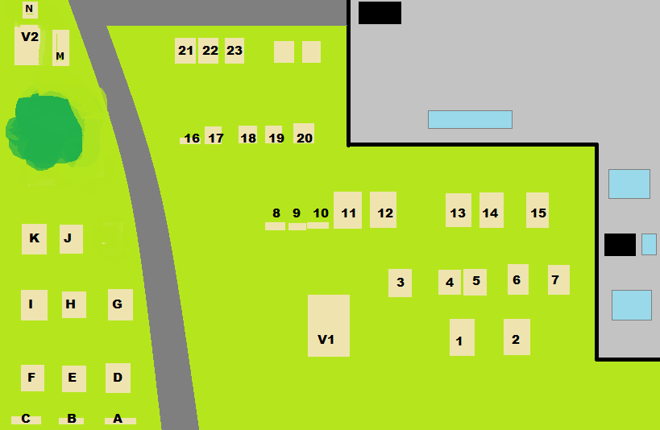
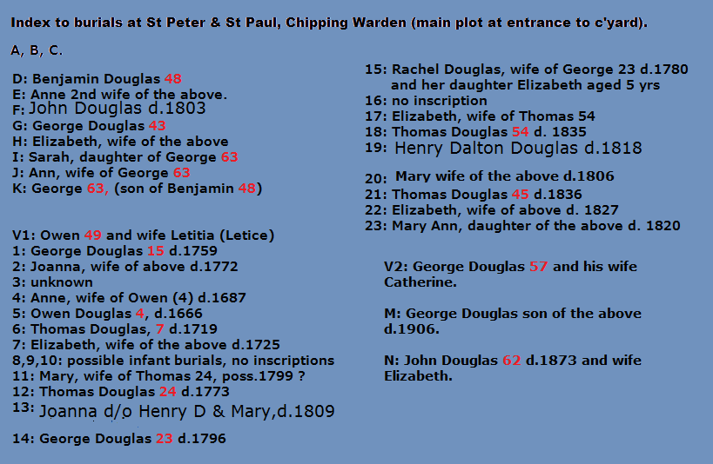
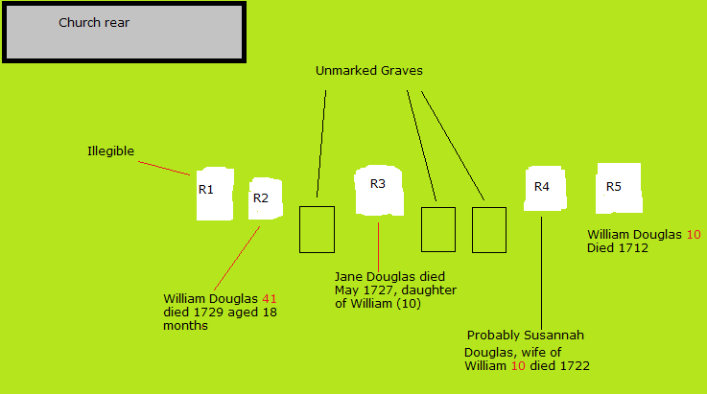
I also visited Byfield again, without any luck. Either the memorials have been vandalised, or they couldn’t afford them. Many markers have been re-sited and most are illegible. One new thing is the village bier, newly restored and in the church porch. This was in use at the time Robert and Julias died.
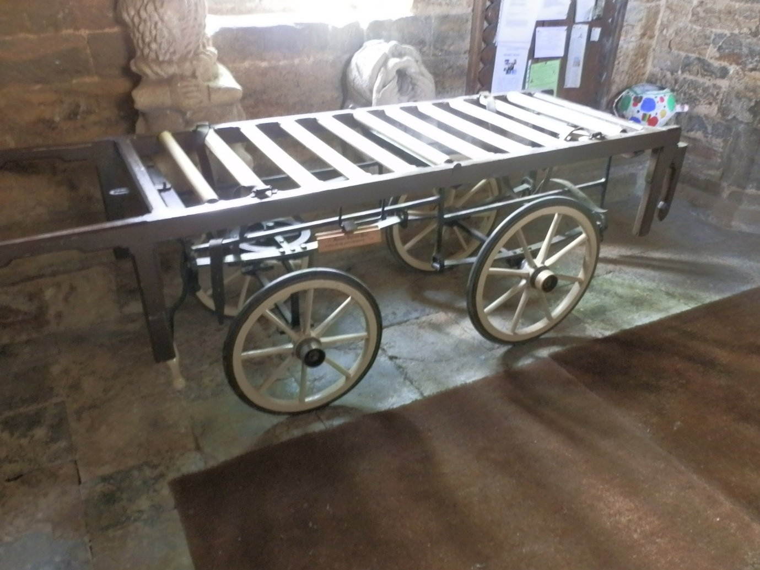
If you would like any photo’s let me know, but they are big files.

Best regards
Nigel Douglas

