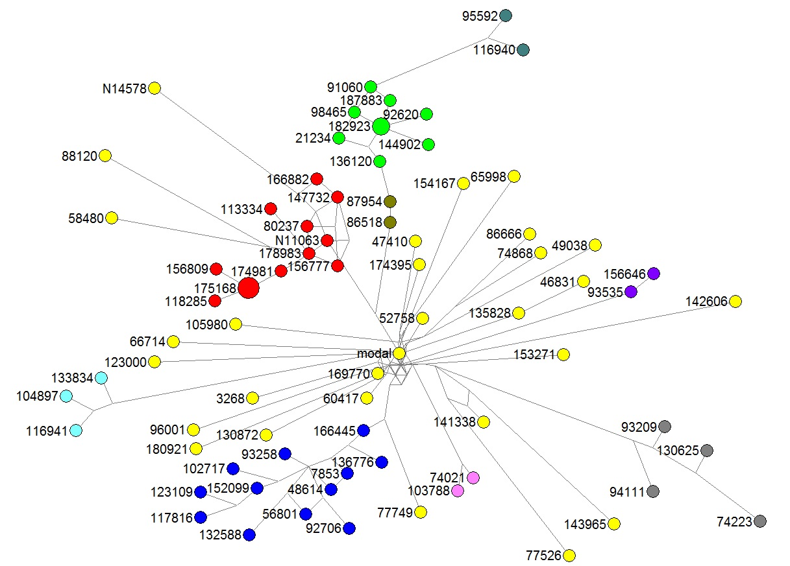

Douglas diagram of the Relationship Tree for 37-marker tests of the R1b Haplotype
Contributed by Belinda Dettmann
This is my first draft of a hypothetical Relationship Tree for R1b Douglas results based on tests with 37 markers, as drawn by the Fluxus Network program.
The dots on the diagram represent the Y-DNA results of the corresponding tests, and the length of the lines joining each pair of dots is proportional to the Genetic Distance (number of mutations) between those two dots.
Analyses indicate that there are a number of recognizable but separate Douglas family groups, colored Red, Dark Blue, Green, Teal Blue, Dark Green, Yellow-green, Violet, Pink and Gray, on the diagram. Large dots represent more than one test with similar DNA signatures at 37 markers. Test results that cannot yet be assigned to family groups are shown here in Yellow.
The large red dot labeled 175168 represents identical results for kits (175168, 78870, 85470). The green dot labeled 182923 represents identical results for kits (182923, 126361).
The different colored green dots are all in the subclade of Niall of the Nine Hostages (R1b1b2a1b5b) and may actually be quite closely related. The main differences between the various green groups is their variation at DYS464, where Green are 15-16-16-16, Yellow-green are 15-16-16-17, and Dark Green are 15-16-17-17. The Fluxus program charts these as though each value of 464a, 464b, 464c, 464d is a single independent marker, whereas the reality is that they are a multi-marker set, with single mutations between each group.

